AI ASSIGNMENT-1

|  |  |
| --- | --- |
| AssignmentDate | 28 April 2023 |
| StudentName | M.SUMITHRA |
| StudentRollNumber | 420620104018 |
| Maximummarks | 2Mark |

1. **Downloadthedataset:Dataset**

[**https://drive.google.com/file/d/160K6XcuYDyRBPGj-**](https://drive.google.com/file/d/160K6XcuYDyRBPGj-JsqThkyFoJhCvOWy/view?usp=sharing)**JsqThkyFoJhCvOWy/view?usp=sharing**

1. **Loadthedataset**.

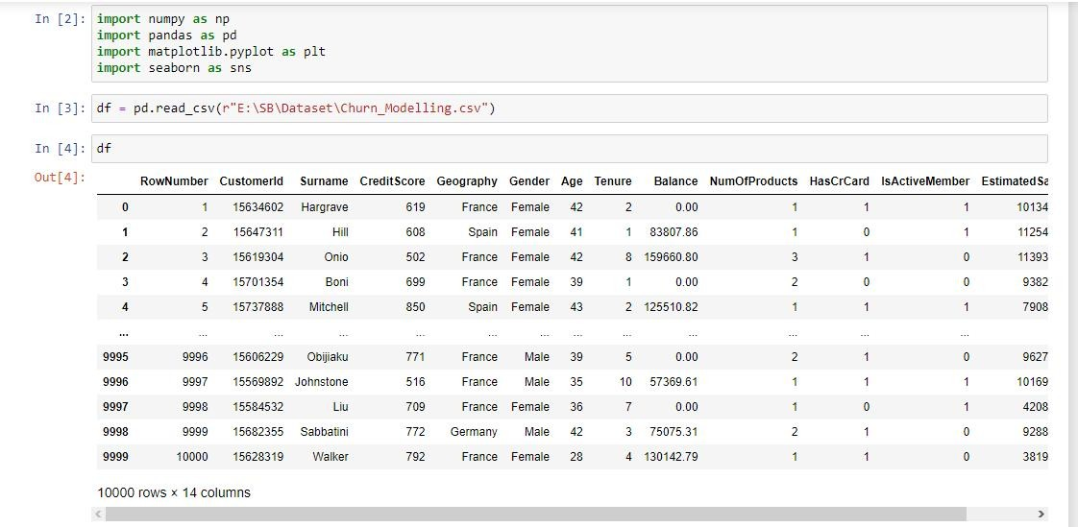

1. **PerformBelowVisualizations:**
   * **UnivariateAnalysis**

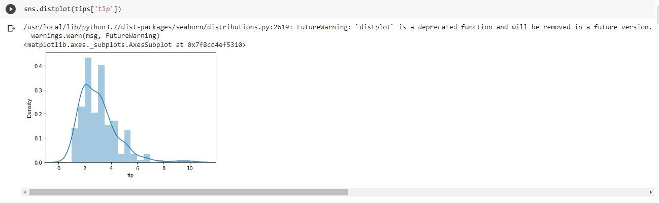

* + - **Bi-VariateAnalysis**

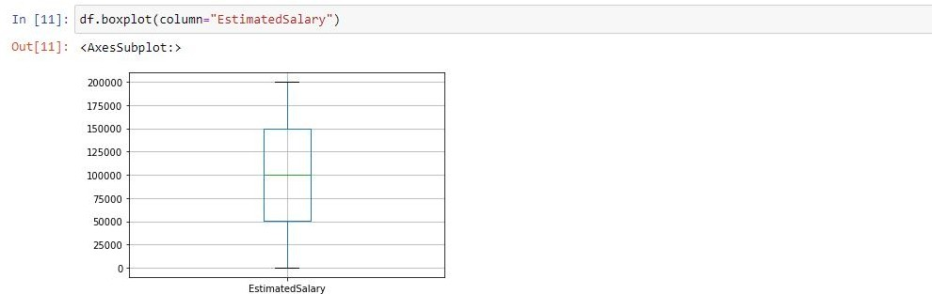

●

* + - **Multi-VariateAnalysis**

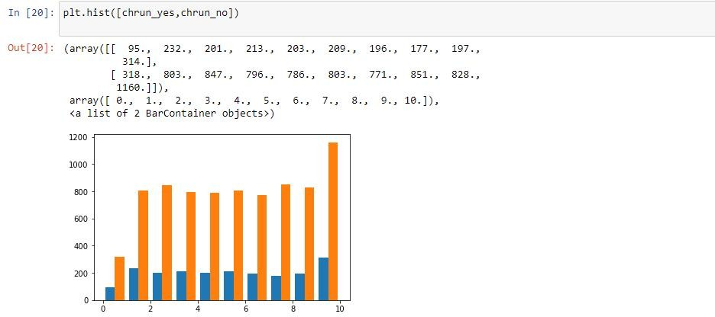

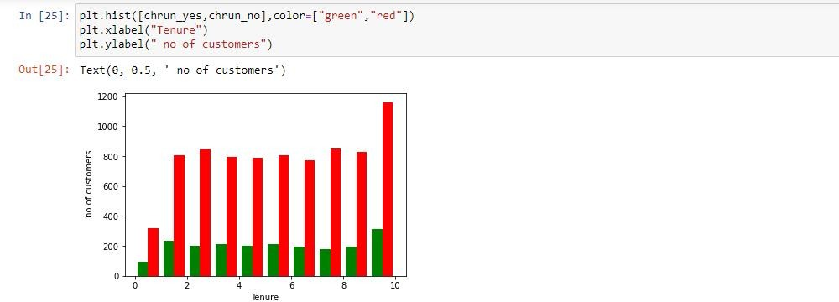

1. **Performdescriptivestatisticsonthedataset**

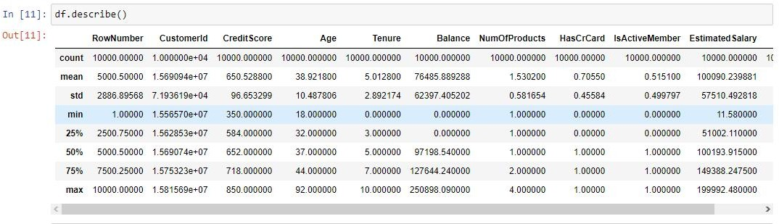

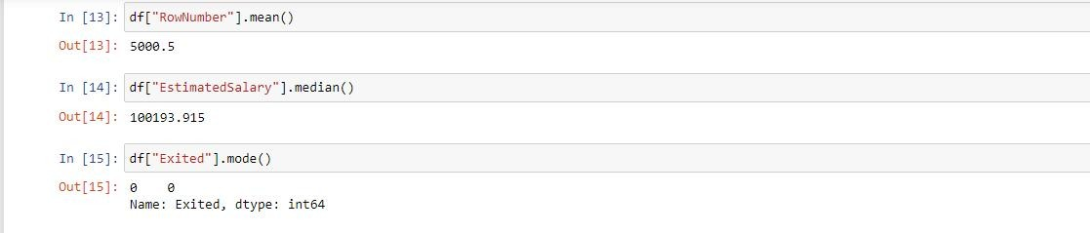

1. **HandletheMissingvalues**.

